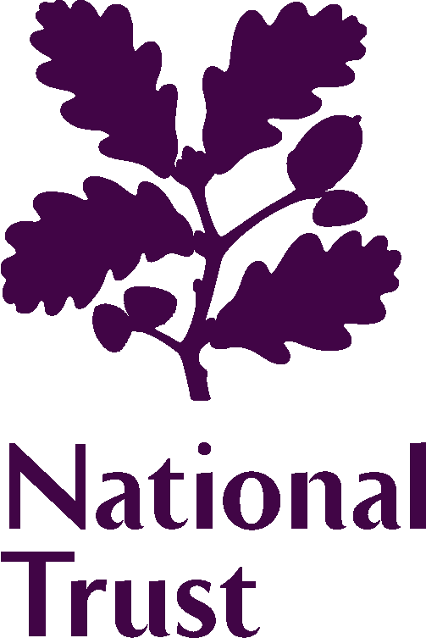 | 2024 Elections to the Council

Where did you first hear about the opportunity to apply to become a Council member as part of this year’s election?
[ ] Acorn  [ ] Arts Council England  [ ] Charity Job  [ ] Diversifying  [ ] Direct email from the National Trust  Governance team  [ ] Facebook  [ ] Instagram  [ ] LinkedIn  [ ] Museums Association  [ ] MyVolunteering  [ ] NED on Board  [ ] National Trust email  [ ] National Trust Jobs website | [ ] National Trust Magazine  [ ] National Trust volunteering newsletter  [ ] National Trust website  [ ] Personal recommendation  [ ] Property staff or volunteers  [ ] Reach Volunteering  [ ] Volunteer Manager’s brief  [ ] Women on Boards  [ ] X (formerly Twitter)  [ ] Young Trustees Movement  [ ] YouTube  [ ] Other (please state)  ……………………………
Were you planning to apply before you saw any advert? |  | [ ] Yes | [ ] No

OUR PRIVACY DECLARATION

We are committed to safeguarding your privacy during the election process. The personal information collected will only be utilized for the specific purposes of the election process for which you have applied. Rest assured, it will not be employed for any other purpose or disclosed to any third party.

Only the information explicitly marked for publication will be made accessible to our members through the election materials we provide and on our website. Your privacy is of utmost importance, and we value your trust in us.

If you have any concerns or questions regarding the use of your personal information, details of our privacy policy are available on our website. Thank you for entrusting us with your information as part of the election process.

YOUR CONTACT DETAILS
Name (as you wish it to appear on the ballot paper)
Membership No
Address
Telephone
Email
Continued over…
YOUR AFFIRMATION
- I agree to stand for election to the Council of the National Trust. I have read the information provided to me about the Council. I understand what being a member of the Council involves, and I am willing to devote the time commitment involved. If elected, I will notify the Chair of any potential conflict of interests which I may have in relation to any item being discussed.

- I confirm that the information given in my application is accurate and complete. I know of no reason why I would not be suitable to become a member of the Council of the National Trust, or which would disqualify me from acting as a Trustee of the National Trust if I were to be appointed to that role in the foreseeable future (see Charity Commission note CC3a).

- I am over 18.

- I have read the Code of Conduct which applies to all members of the Council and, if elected, I agree to be bound by its provisions.

- I have not been employed as a member of staff in the 23 months prior to the AGM in November 2024.

- I understand that I need to be a member of the National Trust, by no later than 1 May 2024, to be able to go forward for election.

- I understand that the National Trust reserves the right not to publish factually incorrect or inflammatory candidate statements.

- In the interests of fairness between candidates, and in compliance with the Trust’s Governance Handbook Clause 2.13.2, I understand that the sole source of publicising my candidacy will be to members via any printed or online election material issued by the National Trust. I confirm that I will not participate in any other methods of publicising my candidature through any other channels or collaborate with others to do so (including but not limited to: broadcast, print and online media, as well as social media).

Signed: Dated:

Election campaigning and material

The National Trust will only publish the information you provide on your candidate information form. This information will be sent to members by their preferred method of communication (digitally or by hardcopy) and will also be published on the National Trust website. In fairness to all candidates these are the sole methods by which candidates should publicise their candidacy and candidates should not undertake any other form of election campaigning.

We are often asked what information can be shared. You can let family, friends and colleagues know that you are standing for election and when voting is taking place, but you should not seek to canvass their support by providing additional information, rather you should direct them to the information available on the National Trust website or AGM Booklet. You should also adopt this approach if you are contacted about your candidacy by external organisations or the media.

