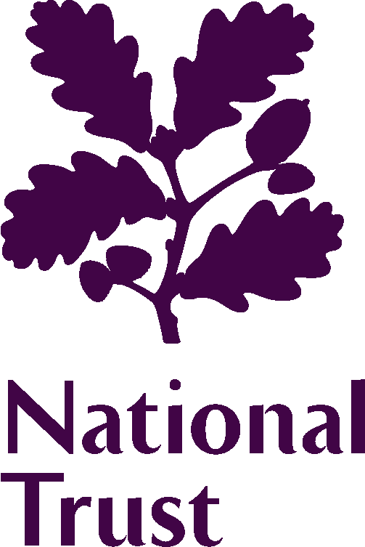 | Regional Advisory Board
 | Member biographies – Dec 2016

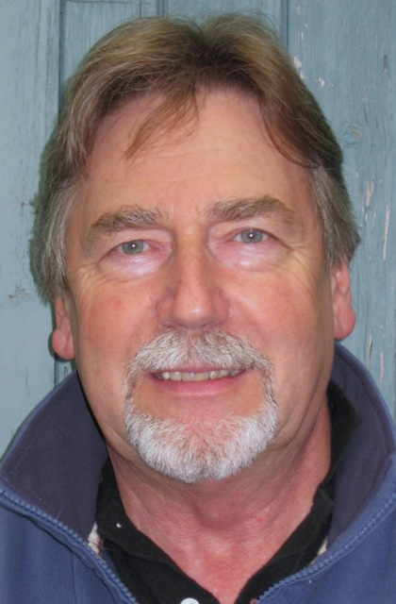  Mr Doug Hulyer (Chair) | Doug began his career developing the first educational nature reserve for the Wildlife Trusts in Surrey. He moved on to work with the renowned naturalist and conservationist, Sir Peter Scott, at Slimbridge in Gloucestershire. At the Wildfowl & Wetlands Trust, he explored new ways of engaging people with wildlife including the leading the creation of the London Wetland Centre, the citizen science programme Pondwatch and the international centres programme - Wetland Link International. He was on the board of Wetlands International and is still a Member of the Commission on Education and Communication for the IUCN.  Doug was one of the founders of the Real World Learning campaign that led to the creation of the Learning outside the Classroom initiative and advised on the Wild Child initiative. He chaired the Public Engagement Group for DEFRA (biodiversity) and was a founder member of the National Trust’s Learning and Visitor Experience Panel.  In 2002, he was appointed to the Council of English Nature, and was a Board member of its successor, Natural England until 2014. He was formerly a Trustee of NHMF/Heritage Lottery Fund and a member of the SW Regional Committee.  He currently runs a small advisory service to not-for-profit organisations in the environment and heritage sectors. He is Chair of the Earth Trust and of the Steering Group for the Jurassic Coast World Heritage Site. He is also a Trustee of the Woodchester Mansion Trust, and a Fellow of both the Royal Society of Arts and Royal Society of Biology.
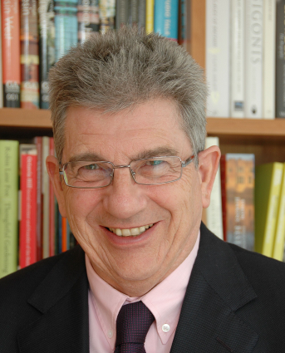  Mr Terence O'Rourke, MBE | Terence O’Rourke MBE is an architect, town planner and urban designer with extensive experience in both the public and private sectors. Since leaving his practice in 2007 he has concentrated on a range of voluntary activities. An active supporter and Patron of the National Trust, he is also Chairman of the Bournemouth Symphony Orchestra, a Governor of the Arts University Bournemouth and sits on the Boards of the Dorset Local Enterprise Partnership and the Arts Council South West. He is also a Director of the Goodwood Estate.
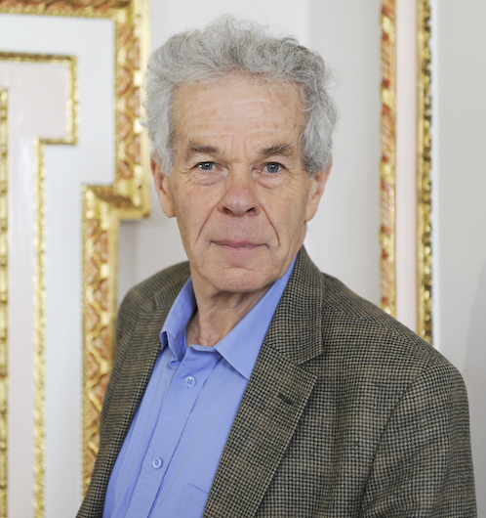  Mr Adrian Phillips | Adrian Phillips lives in Cheltenham. He worked for the UK government, UNEP (in Kenya) and IUCN (in Switzerland) and was Director General of the Countryside Commission from 1981-1992. He then held a professorial post at Cardiff University and worked as an advisor to the Heritage Lottery Fund (which he still does). He has written and lectured widely on conservation and landscape. Internationally, he was a former chair of the IUCN World Commission on Protected Areas (1994-2000). Nationally Adrian has served on the boards of the RSPB, CPRE, WWF-UK, the Woodland Trust and the National Trust (2005-2012). Locally he chaired the Gloucestershire Environmental Trust and was a member of the Cotswold Conservation Board; he is now Chair of the Gloucestershire Local Nature Partnership and works with green groups in Cheltenham.
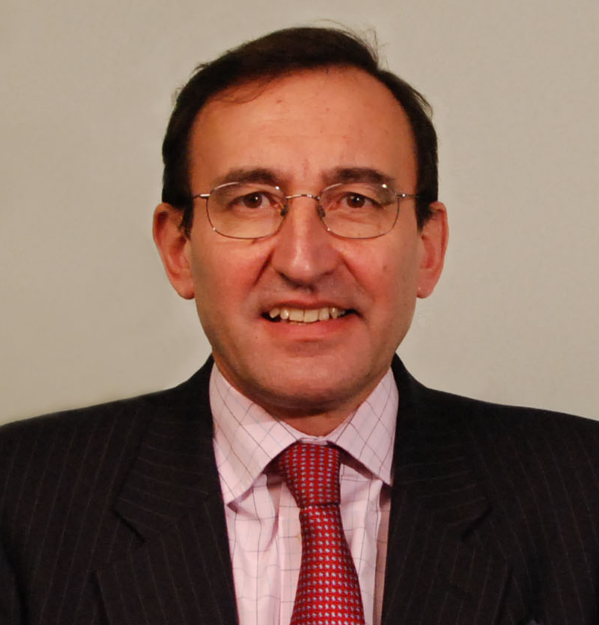  Mr Bob Mark | Bob has been a member of the South West Regional Advisory Board since 2010 and was elected to the Council in 2016. Bob is a Senior Executive Advisor and former Partner with Strategy&, a network company of PWC. Strategy& are global Strategy Consultants. Bob has led major strategy, transformation and organisational change projects with Strategy& in Europe and the Middle East. He was formerly a Rear Admiral in the Royal Navy, spending 17 years as a Royal Navy Hydrographic Surveyor, managing ocean and coastal survey projects in many parts of the World. He has commanded three RN survey ships, and has been responsible for various aspects of UK national hydrographic and oceanographic policy. After completing a fellowship in management science, he switched focus and spent 3 years as the first Director Corporate Strategy for Defence Logistics. His final MOD post was as the Senior Naval Director at the Royal College of Defence Studies in London, which focuses on strategies and policies to promote international security, stability and prosperity. He has been Master of the Worshipful Company of Water Conservators. He is a Fellow of the Royal Institute of Navigation and a Fellow and Chartered Director with the Institute of Directors. Bob and his wife have lived in the SW for over 30 years, during which time they have especially enjoyed walking its coasts. His interests include conservation, the arts and architecture.
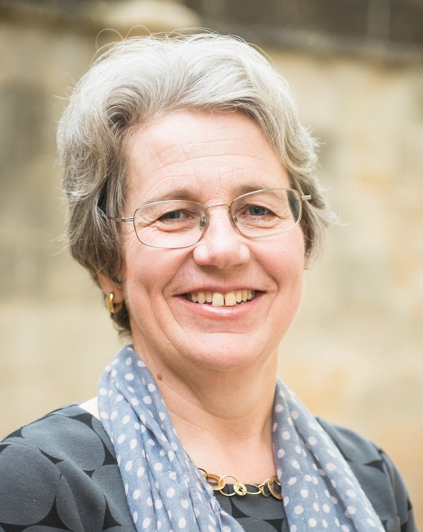  Ms Caroline Kay | Caroline Kay (MA Oxon, MSc) has been Chief Executive of the Bath Preservation Trust since 2007, where in addition to the campaigning remit of the Trust she has led a major lottery-funded refurbishment of the Trust's flagship museum at No 1 Royal Crescent (re-opened 2013). After reading Psychology and Physiology at New College, Oxford, she started her career as a Clerk in the House of Lords. Following a period with the medical research charity the Wellcome Trust, she then became Deputy Director of the Association for Business Sponsorship of the Arts (ABSA – now Arts and Business). She then spent 6 years as a Senior Consultant with AEA Ltd, working on lottery bids for a number of heritage and cultural capital projects such as the Royal Albert Hall, Wiltshire Music Centre and the Whitworth Art Gallery. She moved to the South West in 1998 and worked as an independent consultant for a number of years, including expert assessment work for the Heritage Lottery Fund. She has served as a non-executive/trustee on a variety of arts, education and health boards. She lives in Bradford on Avon.
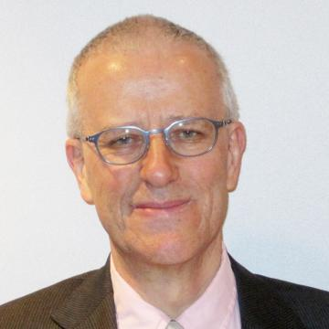  Mr Simon Timms | Simon's enthusiasm for history and landscape stems from his childhood. After his schoolboy ambition to be a jockey came to nothing he pursued a career in archaeology. As County Archaeologist for Devon he helped to inspire Channel Four's Time Team series. He has a particular commitment to opening up the heritage for wider audiences.  Simon is a Fellow of the Society of Antiquaries and a Member of the Royal Town Planning Institute. In 2010 he was appointed chair of the Heritage Lottery Fund's South West committee. Simon was an elected member of the National Trust's Council for nine years and served on the Trust's Board of Trustees from 2005 to 2010. He has also chaired the Trust’s Archaeology Panel.
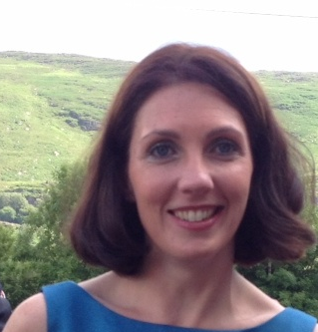  Mrs Laura Padfield | Laura has a professional background in retail and business transformation. She is currently at M&S where she has an International role leading a business transformation programme that will change the general merchandise commercial model. At M&S she has also worked in the UK Food space where she made operation improvements across the supply chain and retail. Prior to M&S she worked for Tesco and before that she was a Strategy Consultant but also qualified as a Chartered Accountant.  In addition to her career, Laura lives on an organic dairy farm just outside Bath with her husband and 4 young children. Her family are fourth generation farmers and artisan cheese producers. During her recent maternity leave she has launched a new farm shop and cafe and started a programme of educational tours on the farm.
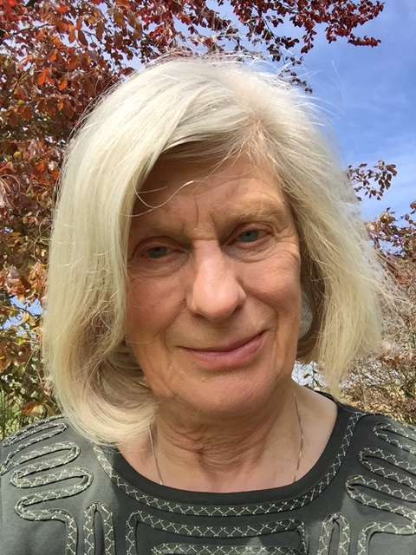  Ms Valerie Brown | Val is currently a member of NT Council (appointed by RSPB). She has pursued a career in academia, specialising in ecology and conservation, particularly in the agri-environment. She was Professor of Agro-Ecology and Director of the Centre for Agri-Environmental Research (CAER) at the University of Reading. Val’s early career was spent at Imperial College, The University of London, from there she become Director of the CABI International Institute of Entomology in London, an inter-governmental organisation, and subsequently its Director of Environment.  Val has served as scientific advisor to Defra and Natural England’s agri-environment research programme for over 10 years. She has been a member of NERC Council, Defra’s Research Priorities Group and Science Advisory Group and English Nature’s Natural Sciences Advisory Group and held positions in various international organisations. She has been Vice President of the British Ecological and the Royal Entomological Societies and Council member of RSPB. She was a member of the UK Government’s ‘Making Space for Nature’ panel, the results of which are now pivotal in landscape conservation goals in the UK. Val has lived in rural Somerset for 12 years and is actively involved in the delivery work of Somerset Wildlife Trust, as a member of its Strategic Advisory Board. In any spare time, Val enjoys gardens and gardening and is a keen bird watcher and field botanist.

